The Nigerian currency, Naira (NGN), is the currency selected for the $1,000,000 FX speculative project. In this project, I predicted that the Naira would depreciate against the USD between March 23, 2020, and April 17, 2020. This prediction is based on the impact of the COVID 19 crisis on the global economy, including that of Nigeria. Nigeria's economy is known to be very fragile, import-dependent, and a mono-economy, which is highly dependent on oil proceeds to meet its foreign exchange demands. The recent dispute between Saudi Arabia and Russia has led to a 50% decline in crude oil prices, which is the mainstay of the Nigerian economy. Therefore, it is my opinion that the currency will depreciate against the U.S dollar within the study period. As such, I will be going short on the Naira and converting my cash from Naira to $1,000,000 with the expectation of protecting the value of my investment and profiting from the transaction.

Table 1: Exchange rates - NGN per USD

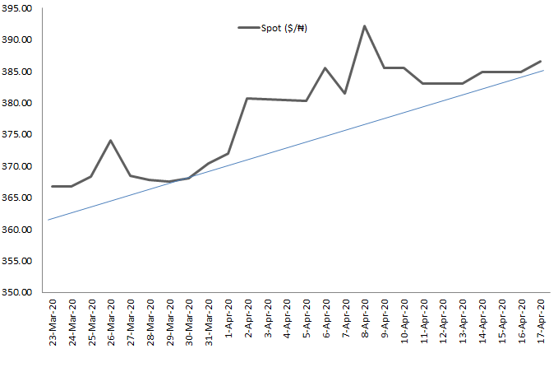
Figure 1: Exchange rates - NGN per USD

$ARR=\left(\frac{{SR}_{Apr 17}- {SR}_{Mar 23} }{{SR}_{Mar 23}}\right)100* \frac{365}{n}$

$$ARR=\left(\frac{386.63-366.71}{366.71} \right) 100* \frac{365}{25} =79.31\%$$

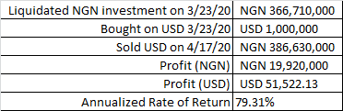
Table 2: Annualized Rate of Return

Table 2 contains a snapshot of the FX speculation project and the annualized rate of return earned from the investment. A look at the table shows that the decision to go short on the NGN was appropriate. Naira, which opened at USD/NGN366.71 at the start of the project, came under immense pressure during the period resulting in a 5.4% depreciation to close at USD/NGN386.63. The short position yielded a profit of 19.92 million Naira or USD51, 522.13 for 26 days resulting in an annualized rate of return of 79.31%.

Possible Reasons for Naira Fluctuation
The performance of the Nigerian currency is intricately tied to movement in global oil prices. Nigeria depends on the sales of crude oil to meet 85% of its foreign exchange needs. Therefore at a time of significant oil supply glut occasioned by the rift between Russia and Saudi Arabia and global inactivity, it was almost inevitable that Naira would be negatively impacted.

Another potential cause of the fluctuation of the Naira is that the country's foreign reserves, which stood at $42 Billion about six months ago, had plummeted to $ 36 billion by the end of March, as shown in the chart below. This amount is barely enough to cover seven months of imports. Consequently, the CBN, who is the major supplier of foreign exchange, has not able to provide the needed FOREX to end-users due to declining reserves causing a spillover in demand to the parallel market, which is mostly unregulated.

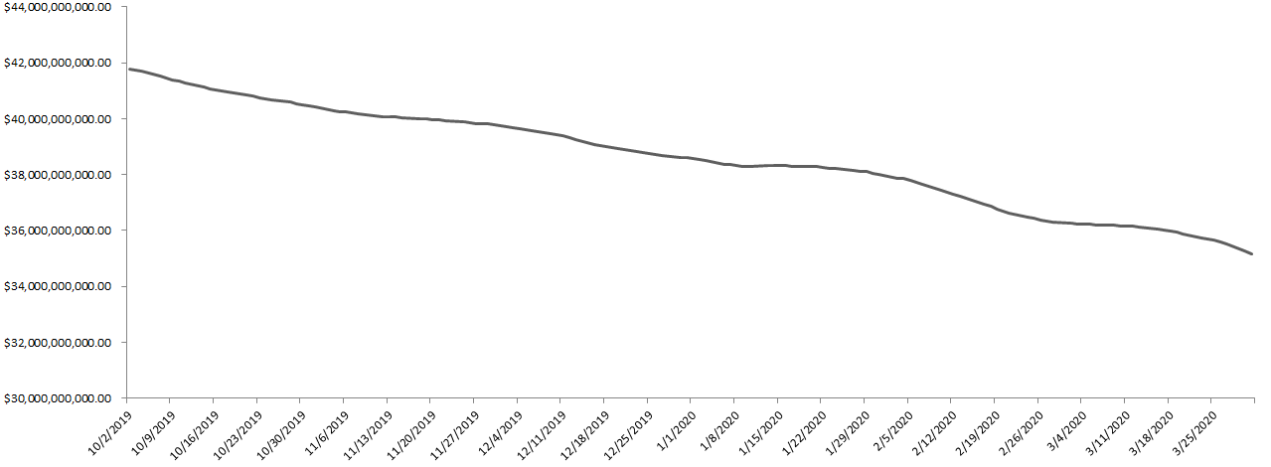
Figure 2: 180 days Movement in Foreign Reserves
The huge fluctuation in the value of USD/NGN can also be attributed to a Central Bank of Nigeria circular dated March 31, directing banks to sell FOREX to qualified end-users at NGN 380 to a dollar as against NGN 363 (Proshare, 2020). This announcement of a technical depreciation sent panic into the financial market as people scrambled to frontload their FX obligations.

Also, the Nigerian government suspended its proposed $22.7 billion loan from the World Bank, IMF, Islamic Bank of Saudi Arabia, and the Chinese government earlier in February (Baiyewu, & Onuba, 2020). The loan was expected to help shore up the value of the NGN and help infrastructural development in the country. Similarly, a $3.0 billion loan scheduled to be raised in the first quarter of 2020 via Eurobonds was suspended in the wake of the coronavirus outbreak.

Investors and exporters can mitigate the impact of exchange rate fluctuations using currency hedging. Currency hedging is a risk mitigation strategy in international trade to protect against both unexpected and expected changes in exchange rates. A typical example of this is to enter into a forward contract for the period of the trade or investment. A forward contract is an agreement between a buyer and a seller to trade an asset at a future date. The essence of using a forward contract is to lock in an exchange rate at a price set today for future delivery. The cost of using a forward contract is usually about 1.5% of the contract amount but cheaper than bearing the consequence of exchange rate fluctuation.

Currency Hedging
Consider a typical example of a U.S exporter of Bourbon expecting to receive $1,000,000 in three months as proceeds of sales of Bourbon in Nigeria. The funds will first be earned in Naira before being converted into USD at the prevailing exchange rate. Assuming a scenario where the value of USD remains constant, and Naira experiences 10% depreciation, I would earn $909,090 when the sales proceeds come in, resulting in an exchange rate loss of $91,000 without currency hedging.
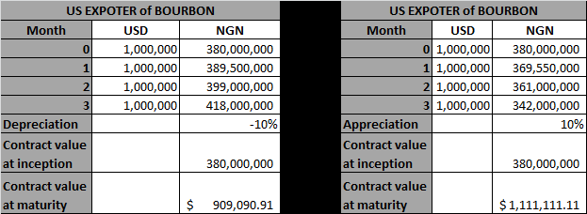
However, with a forward contract, as shown above, I would have received the Naira equivalent to purchase $1,000,000 even at the cost of 1.5% being the forward contract fee. This would result in $985,000 at the end of the contract versus $909,090 without hedging. Similarly, without hedging and assuming a 10% appreciation of the Naira, I would earn $1,111,111 at the expiration of the contract. Hedging would only result in $15,000 less, which is a better option than allowing the consequence of a fluctuating exchange rate to crystalize.
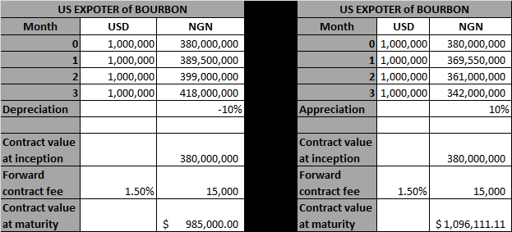
As seen in the example above, when faced with uncertainties about future payments or fund receipts, forward contracts can be used to manage those uncertainties within a fixed budget and effectively eliminates the risk of potential losses from adverse market movements. The main disadvantage of using forward contracts is that they are not liquid, unstandardized, and has a high default risk. Options and futures contracts are other means of hedging investments against currency fluctuations.

Conclusion
Exchange rate fluctuations could have a significant impact on investment proceeds and overall profitability. Currency heading helps in smoothening uncertainties due to currency fluctuation and protects the value of an investment.

References
Baiyewu, L., & Onuba, I. (2020, February 12). Reps suspend Buhari’s $22.79bn loan consideration indefinitely. https://punchng.com/reps-suspend-buharis-22-79bn-loan-consideration-indefinitely/
Proshare. (2020, March 31). CBN Responds to global economic conditions, depreciates Naira. https://www.proshareng.com/news/%20BONDS%20&%20FIXED%20INCOME/CBN-Responds-to-Global-Economic-Conditions--Depreciates-Naira/50003

